1. **Class Design:** Imagine you are developing a software package for a company. The package has the following classes.

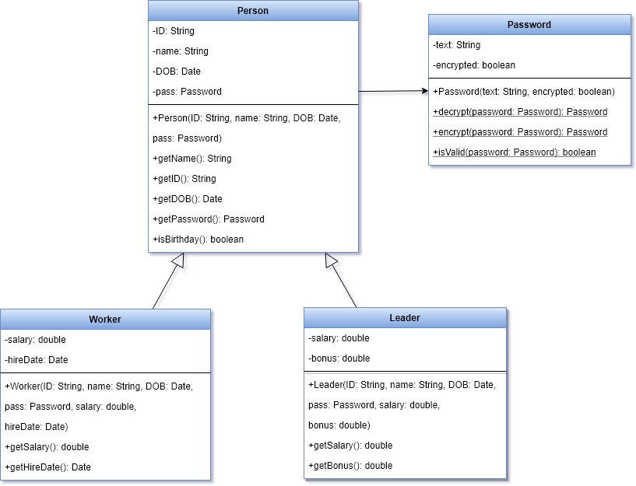

* Password class
  + The text field stores the password string
  + The encrypted field states that the password string is encrypted or not
  + The valid password must meet the following criteria
    - It should be at least eight characters long
    - It should contain at least one uppercase and at least one lowercase letter
    - It should have at least one digit
  + The encrypt method read each character of the password string, and add **1** to the **character code** of the character
  + The decrypt method read each character of the password string, and subtract **1** from the **character code** of the character
* Person class
  + Employee number is in the ID field in the format XXXX–L, where each X is a digit within the range 0–9 and the L is a letter within the range A–D.
  + Employee name is in the name field
  + Date of birth is in the DOB field, where it must be within the range 1950-2000.
  + Password is in the pass field
* Worker class
  + Salary must be greater than 100$
  + Hire date is in the hireDate field. Notice that the company cannot hire a person who is less than 18 years old
* Leader class
  + Salary must be greater than 200$
  + Bonus must be greater than zero. In addition to a salary, the leader earns a bonus

*Note: Worker Income = salary; Leader Income = salary + bonus*

Implement the classes and demonstrate how to use the classes

1. **Files & Exceptions:** Assume that the company stores the staff information in a text file.

0000-A, Khang Nguyen, 31/12/1990, Abcdef12, true, worker, 200, 31/12/2010

0001-B, Dung Bui, 31/12/1980, Abcdef13, false, leader, 200, 50

…

Design a class that has

* A static method named openData. The method should take the name of a file and return a reference to an array of Person. It should handle some exceptions such as *the file is not found*, *the data is not valid*
* A static method named printList. The method should take a reference to an array of Person. It prints the list of people who are greater than 20 years old and their incomes are greater than 1000$.